Cabrican, Quetzaltenango, Guatemala February 28th 2022.

Report of the Educative’s Project Cabrican-Huitan

This school is ready to celebrate his 60 anniversary this year. The school has one year working with this new administration coordinated by the piarist. The Piarist Fathers are an Order Religious that was founded in 1617 by Saint Joseph of Calasanz, who discovered that education is the key for changing the world and the society.

Last year we had the coordinator of the Santiago Apostol’s Parish, so we are the responsibilities of the colleges that this foundation has helped for many years and we’re so happy that you continue working on this great work.

Sister Lilia has helped us so much with this new reality and we’re so happy to be here and we want to work together to continue helping these guatemaltecan people. I know that I need to send the financial report of the last three months of 2022, and I know that you reviewed the financial reports from January to October 2021. In this report you can see all the economic situation about the school.

In this first year we discovered a little the context of this parish and of the family who are inside of our school. We continue finding so many wonderful experiences inside of this town full of great spirituality. Also our schools are a perfect space where we can start to change the lives of these people. Truly the school can be one opportunity for grounding all the senses, and this is the reason by which we can ask you for your help.

We want to say thanks for all the followers that you have obtained for these German families. We are so happy to share with you all the activities that we do in this land. And we want to invite you to share with more families ours net social. The three social nets that we have are:

Facebook
Escolapios Guatemala
Parroquia Santiago Apóstol Cabricán-Huitán Escolapios
Colegios Parroquiales Escolapios Cabricán-Huitán

Instagram
@schp_guatemala
@colegiosparroquialesschpcabricanhuitan

And our mails are

escolapiosguatemala@gmail.com
colegiosparroquialesschpcabricanhuitan@gmail.com

We hope that we can be in contact this way and we can work together. Similarly the What’s App of the Parish is +502 5728 0884 and for the school +502 4509 6756.

The persons that this year are working with us are:

College The Assumption

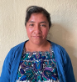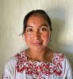

Angélica María Ramírez y Ramírez Floresmilda Violeta Ramírez Baten
Kindergarten’s teacher 1st grade teacher
19 years working for us 11 years working for us

Reyna Victoria Ramos López Santiago Vidal Baten Clemente
2nd grade’s teacher 3rd grade´s teacher
13 years working for us 5 years working for us

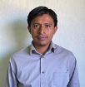

Edi Enrique Ramírez y Ramírez Alberto Feliciano Ramírez Ramírez
4th grade’s teacher 5th grade’s teacher
5 years working for us 6 years working for us

Oscar Baldemero Pérez y Pérez Santiago Waldeim Sontay Vicente
6th grade’s teacher Music´s teacher
11 years works for us 9 years working for us

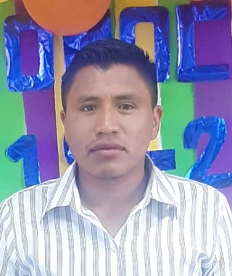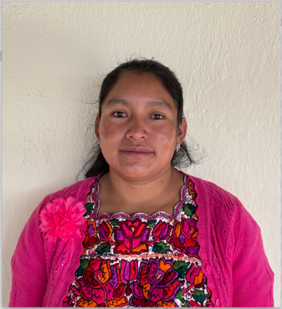

Abner José Lucas Pérez Candelaria Verónica Pérez Baten
Physical Education´s teacher Secretary
First time working for us First time working for us

College Saint John Baptism

José Luis Alfredo Velázquez Lucas
Principal
4th, 5th, 6th teacher’s elementary
6 years working for us

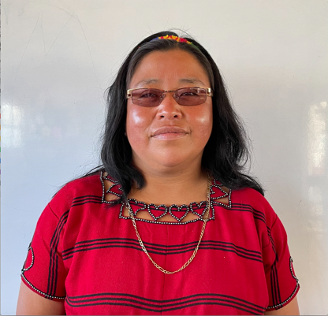

Delmy Susana Méndez Pérez Magdalena Castro Bartolo
1st, 2nd, 3rd teacher’s elementary Secretary
1 year working for us First year working for us

CEPEMH

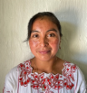

Irinero Abel Lucas Castro Floresmilda Violeta Ramírez Baten
Principal Communication and Lange,
15 years working for us Natural Sciences,
Values and education
Guide teacher of 1st
8 year working for us

Alberto Feliciano Ramírez Ramírez Edi Enrique Ramírez y Ramírez
Mathematics, Education and values, English, Values and education,
Guide teacher of 2nd A Natural Sciences
5 years working for us Guide teacher of 2nd B
4 years working for us

Oscar Baldemero Pérez y Pérez Santiago Waldeim Sontay Vicente
Social Sciences, Music´s teacher
Entrepreneurship for the productivity 9 years working for us
Natural Sciences
Education and values
Guide teacher of 3rd
11 years working for us

José Luis Alfredo Velázquez Lucas Aura Marina Méndez Méndez
Technologic for the learn and communications Culture and maya language
6 years old working for us 1 year working for us

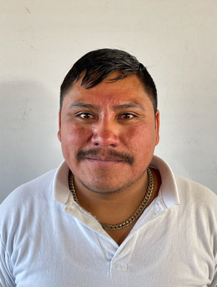
Jesús Amilcar Velázquez Méndez Abner José Lucas Pérez
Entrepreneurship for the productivity Physical Education´s teacher
First time working for us First time working for us

The community of the Piarist Fathers on Guatemala is:

Fr. Julio Aarón Cahuantzi Bello, Sch. P.,
The parish

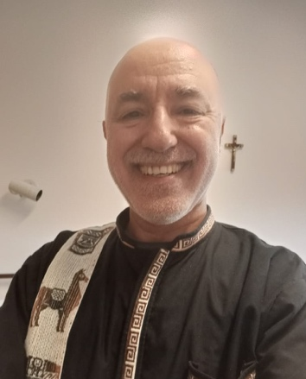
Fr. Ruben Plata, Sch. P., Br. Cristian Bacar, Sch. P.
The vicarian Community’s member

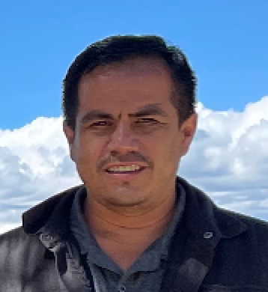

Jr. José Manuel Serrano, Sch. P. Mr. Francisco López Jiménez
Piarist Junior Responsible of the colleges
On the plans that we have, we wanted to open the next years Básico, Middle School, on Cabricán and the High School on Huitán. But this year we found different situations that we must resolve before opening these new sections in our schools. Some of these situations are the guatemaltecan rules about the taxes and, especially, the financial support of these new classes. We are thinking too that the best option to continue the next section will be on Cabrican because there we have more space and more installations; in Huitan we have little space to open new classes.

We are so happy because these days we have found other alternatives for obtaining the permission for open de Basic on Cabricán and this permission is validated by 5 years; so, if we obtain the authorization for open de Basic this year we will have 5 years to organize this news section in the best way. We are sure that with this best educational space the youth of this land will have better opportunities in their lives. In the same way, we found in the education central´s office that we can change the Basic of Huitán and become a School by Cooperative; with this governmental help we could open our projects easier because we would have more money that we could use to give the best education in our school.

Another idea that we have, but that we know that we can’t open now, is the Youth Hostel for all the young that live so far from the school can study with us in our schools. We think that this new hostel only makes sense if we open the high school in some of our schools.

We know that we have news visions, but we are sure that with your help and trust we can continue walking in a good way. We hope that all the fields of the parish and all the products that we can get from them will have the necessary for making these news dreams on news realities like Fr. Pedro truly wanted it.

We hope that this report helps to build a new school and we can help to provide a better way to all these people that need so much the pietas et letters.

Sincerely

Mr. Francisco López
Responsible of the colleges

